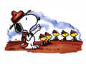I am an educator.

I am passionate about supporting the growth and education of others.

I believe in empowerment. I will treat all people with respect. 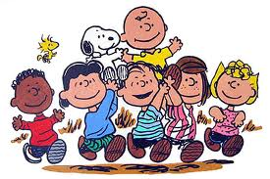

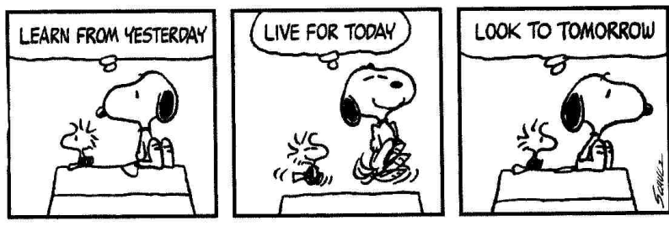

In relationships with my students, parents, coworkers, administrators and school community, I will strive to be humble, considerate, honest, kind, forgiving, and wise.

Each day I will say something kind to, and about someone else;

thank those who have helped me, and do something kind for someone else.

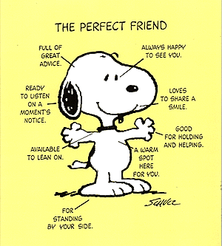

I value and keep my word. In everything I do, I will be guided by my values and shall give it my interest, my enthusiasm, my heartfelt passion, and most importantly, myself.

I hold myself accountable and give myself credit. 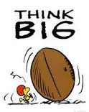

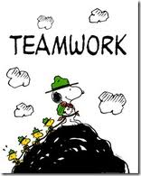

I am part of a larger community – as such,
I will encourage and support the dreams and aspirations of others, learn about others, and contribute to the betterment of my community.

I accept as true the benefits of laughing .

I will encourage students to share corny jokes regularly.

Paying attention to details is an essential element of learning. 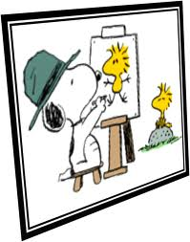 I will continue to draw caricatures since it helps me to stay in practice of observing details.

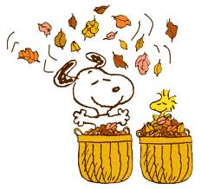A well “raked” lawn in the fall is a beautiful thing, but I’d rather play in the leaves. I must plan, set priorities and manage my time well to be an effective teacher being mindful to add in the “fun stuff”.

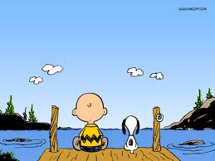 I think that listening to the harmonious sounds in nature is like hearing the hum of a everyone working together in class…music to my ears <3. I will guide students to learn how to work together and resolve conflict.

I believe in working hard, giving it all you’ve got and not giving up!

Then, play with a Nerf football. Why not?

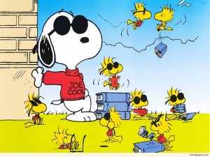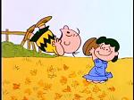

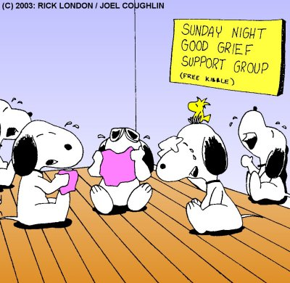 Talking openly about trials and tribulations assist people to realize they have more in common than they may have thought. Therefore, I will talk over things openly being mindful to “be kinder than necessary, for everyone you meet is fighting some kind of battle.”

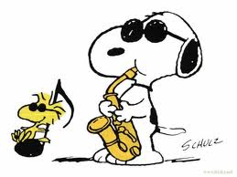

Listening to music and singing as a class is like peanut butter and jelly between 2 pieces of bread: it holds things together! No, I don’t have the best “singing” voice, but so what. It’s fun, exhilherating and educational to sing patriotic songs in the morning, “Happy Birthday” on those special days and be exposed to NJ musicians. It’s all good. I will sing and listen to music with my students daily in class.

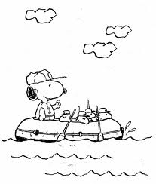

I have faith in my students to embark upon new voyages safely

and I will challenge them to do so.

NOTE TO SELF: Add water-wings to the class supply list

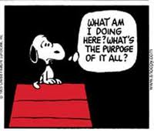 The saying that “Life is what we make it” is well founded. I will take time to reflect, set goals, reposition as needed and celebrate success.

A good night’s sleep for those who are on the go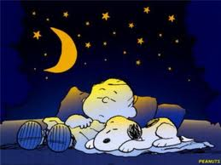 is like a fully charged battery to a cell phone: a necessity. Everything runs a bit smoother and a little faster when it’s got the energy it needs. I will get the rest I need nightly and remind students to do the same. I will also take breaks with the class as needed to revitalize to become more productive.

